**Lesson Nineteen: The Last Week of the Life of Jesus – I**

**Jesus Arrives and Is Feasted at Bethany**

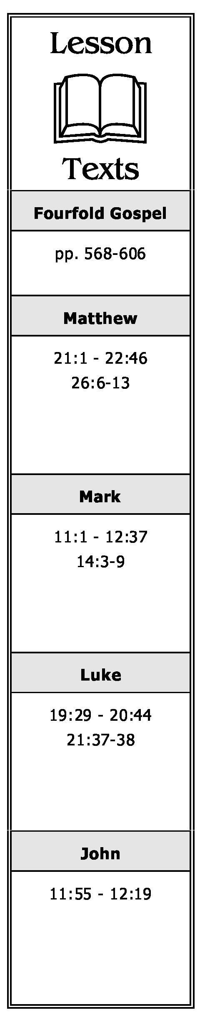

**(John 11:55 - 12:11; Matthew 26:6-13; Mark 14:3-9)**

1. When Jesus visited the home of Mary, Martha and Lazarus in Bethany six days before the Passover, what did Mary do for Him?
2. Who criticized Mary's actions? What was the criticism? How was it answered?

**Jesus’ Triumphal Entry into Jerusalem**

**(Matthew 21:1-11; Mark 11:1-11; Luke 19:29-44; John 12:12-19)**

1. How did Jesus enter Jerusalem? Why did He choose to enter the city in such a manner?
2. What was the reaction of the multitudes to Jesus as He entered the city? What did they cry out concerning Him?
3. What was the reaction of the Pharisees to Jesus' entry into the city?

**The Barren Fig Tree. The Temple Cleansed**

**(Matthew 21:18-19, 12-13; Mark 11:12-18; Luke 19:45-48)**

1. Why did Jesus curse the fig tree?
2. What did Jesus do when He went into the temple? Why?
3. What is meant by the expression “den of thieves?”
4. What did the chief priests and scribes want to do to Jesus? Why did they not do it?

**A Chronological Study of the Life of Jesus Gene Taylor 50**

**Finding the Fig Tree Withered (Matthew 21:20-22; Mark 11:19-25; Luke 21:37-38)**

1. Upon seeing the fig tree that He had cursed dried up from its roots, what application does Jesus make to His disciples?
2. During this period of time, how was Jesus spending His days? Where was He spending the nights?

**A Third Group of Parables Introduced (Matthew 21:23-27; Mark 11:27-33; Luke 20:1-8)**

1. With what question did the chief priests and elders confront Jesus? How did He respond?
2. Why did the chief priests and elders not answer the question Jesus asked of them? Since they would not answer His question, what did Jesus do?

**The Parable of the Two Sons (Matthew 21:28-32)**

1. Briefly summarize this parable. What is its main lesson?

**The Parable of the Wicked Husbandmen (Matthew 21:33-46; Mark 12:1-12; Luke 20:9-19)**

1. Briefly summarize this parable. What is its main lesson?
2. How, by this parable, did the Jews pronounce their own condemnation?

**The Parable of the Marriage of the King's Son (Matthew 22:1-14)**

1. Briefly summarize this parable. What is its main lesson?
2. What happened to the guest who came to the marriage feast but was not wearing a wedding garment? What application did Jesus make of it?

**The Pharisees and Herodians Ask About Tribute (Matthew 22:15-22; Mark 12:13-17; Luke 20:20-26)**

1. What question did the Pharisees and Herodians pose to Jesus? Why did they ask such a question?

**A Chronological Study of the Life of Jesus Gene Taylor 51**

1. How did Jesus respond to the question the Pharisees and Herodians had asked Him?
2. What reaction did the Pharisees and Herodians have to the answer Jesus gave them?

**The Sadducees Ask About the Resurrection (Matthew 22:23-33; Mark 12:18-27; Luke 20:27-39)**

1. Did the Sadducees believe in the resurrection? What was their question to Jesus? Seeing their lack of belief in the resurrection, why did they ask such a question?
2. What was Jesus’ answer to the Sadducees? How did the multitudes react to Jesus’ answer?

**A Lawyer Asks About the Great Commandment (Matthew 22:34-40; Mark 12:28-34; Luke 20:40)**

1. What question did a lawyer ask of Jesus seeing that He had silenced the Sadducees?
2. What answer did Jesus give the lawyer? Why was His answer correct? (Cite evidence which shows the commandments Jesus cited are “greatest.”)
3. How did the questioner respond to the answer Jesus gave him? In turn, what did Jesus now say of him?

**Jesus’ Question Which None Could Answer (Matthew 22:41-46; Mark 12:35-37; Luke 20:41-44)**

1. What question did Jesus ask the Pharisees which silenced them?
2. What was the attitude of the “common people” toward Jesus?

**A Chronological Study of the Life of Jesus Gene Taylor** 52